**Project ‘AASHA’-SAP Implementation at STAR Corporation**.

**Background:** STAR Corporation is well known organization into manufacturing of Tea & Coffee. It is Indian MNC with presence in US & Middle East countries. It has two manufacturing plants in India located at Pune & Kolkata. The first division called the Tea division is located at Pune which caters to large scale Tea production and are made to Stock. The second division located at Kolkata called Coffee division serves to small scale customers who give repetitive orders. These products are mainly used for commercial as well as household purposes and are manufactured to stock (Made to Stock).

Company has Central Sourcing division located at corporate office in Pune and caters to 60% of

procurement done centrally for all the plants. This is to take advantage of volume discounts with

vendors. Plants have their own purchasing function which looks after local vendors.

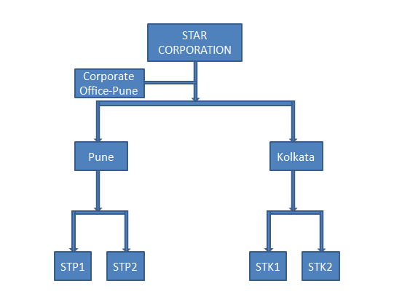

**Overview:** Organization has decided to implement ERP to bring standardized system-based approach to business and optimum utilization of resources. It also wants to benchmark and modify current business processes with Industry standard.

**Following are the main Business objectives-**

* Optimum utilization of resources (raw material, people, machine, finance, etc.)
* Developing system driven approach to business rather than people dependent
* Developing real-time decision support system to manage volatile & fast changing market scenario.
* Benchmarking of current business processes with Industry best practices.
* Put system control on business sensitive information.
* Developing Total visibility and improved process efficiency.

**Project Scope for Materials Management:**

Organization follows Centralized approach for materials procurement and inventory management. While strategic sourcing is centralized to take advantage of volume, local vendors are looked after by divisional purchase departments. Following are the business scenarios which needs to be mapped in SAP.

There are some materials which are procured in domestic market and from international market also. This is based on need and market availability. It is observed that there is considerable difference in price for domestic and import procurement. To reflect correct consumption values in P&L statement, organization desires to valuate these materials differently and at the same time wants to avoid duplication of material master data.

Print & stationary items are difficult to quantify at the time of ordering. Organization wants to have lump sum contract with vendor.

Organization has highest priority for Customer delivery, and it has implemented better inventory systems. These systems have helped in improving operational efficiency and decreasing product delivery time. To support these systems, organization has tied up with few vendors who have kept their material in its store. This helps in material availability.

For certain materials there are multiple suppliers. Organization wants to create healthy competition to get the business. Based on certain quality Parameters, system should calculate the rating and one with favorable rating should get the defined Quota of business.

To avoid the low-quality suppliers entering the vendor base, organization wants to follow strict vendor registration process. The Central sourcing department will own the vendor registration and after due diligence they would approve the vendors for different plants.

Certain materials are sent outside for specific process at vendor premises. This is to take advantage of specific vendor expertise, to lower the cost of production and increase the production capacity.

Vendor payments are most important area in which Organization wants to improve the visibility through availability of real time information on the status of vendor payments.

Organization wants to analyze the procurement of materials. Based on this analysis, certain materials which are procured periodically by divisions will be shifted to central procurement department to take advantage of volume discount.

Central purchasing function wants, system to keep track of volume-based Discounts.

**Team A**: Need to configure the Organizational Structure along with central Purchasing Organizations and Reference Purchasing org if needed. They also need to make sure that to reflect correct consumption values in P&L statement, organization desires to valuate these materials differently and at the same time wants to avoid duplication of material master data. There are contracts with some vendors for which both the plants can make use. Some materials required on a daily and weekly basis also have agreements with vendors on a quantity basis. Different Document types along with separate number ranges should be available for Service Subcontracting and normal Purchase orders along with Stock transfer orders. If the materials must be returned it should be through a return purchase order.

**Team B**: There are some stocks like Caffeine which must be transferred between the plants when they are required urgently if procurement locally takes time. So, they need proper documentation which should be done when transferring between plants. The Pune Plant office is setup on a rental basis for which monthly rent of 20k is paid. There are vendors who keep their consignment with us they are only paid when we use the material. The Vendors of import and domestic should have different number ranges starting from 3 and 2 respectively. The Vendors should be not always chosen by individuals and to avoid that each vendor should be subject to quota according to which they should be sent purchase orders.

**Team C:** Materials are of different types like raw, semi, finished and packaging which should have different number ranges. Pricing must be different for the domestic as well as the foreign vendors. Also, adequate discounts are given by vendors when the materials are purchased in bulk, so the pricing must cater to that as well. The pricing also must be different for the local materials i.e. same materials which are purchased from domestic vendors and foreign other than those. Also, some of our trusted vendors do not send us invoices so special provision has to be made for them. Gas supply is required for some work centers and for that gas is procured and paid accordingly. In case vendors have are not paid fully because of incorrect invoice, the invoice is not cancelled, and they are paid subsequently. Stationery materials and advertising materials should be handled differently, and their cost should be shown in different accounts.

**Team D**: Some materials are subject to be handled in batches. The materials which are subject to expiry must be consumed first and should happen automatically as there can be instances when there are a lot of batches and it would be difficult to identify which expires first. The material which are split valuated other than the batch materials which can also be consignment stocks along with in house production and externally procured materials should be consumed with stock determination as the factory wants to have the option of choosing between these different types. Materials are subject to Periodic Physical inventory and they should be adjusted according to the store level. Some consumable materials must be planned for every 12 months according to their historical values. The company would also like to see the various stock reports according to the pending Invoice and GR. Purchase requisitions created through MRP in bulk should be assigned source and purchase orders should be created automatically for them.

**Team E**: All the External Purchase documents are subject to 5 levels of approval depending on the value. If the value is within 5K should be just 1 approval of Purchase manager. If the value is more than 5K and within 25K it should be approved by the Purchase manager & Supplier Manager. If the value is within 50K and more than 25K it should have approval of Purchase Manager Supplier Manager and Operations Manager. Anything of value more than 50k and within 1 lac should have the approval of General manager along with the other 3. Above 1 lac should have all approvals along with the Vice President.

The packaging materials are generally manufactured in the factory with a special machine for it. But the outer label and paint is done from a subcontractor outside. Also, for some materials procured which are brought in cartons. They should be returned when they are empty. In case of shortage of stock and the customer requires stock, we supply it through our sister concern directly to the customer.

There should be agreements and fixed vendors for respective vendors when they are created along with overall release.